Day 2- MSSQL Query

Name: E.R Harish

1. **Storing Data in a Table**

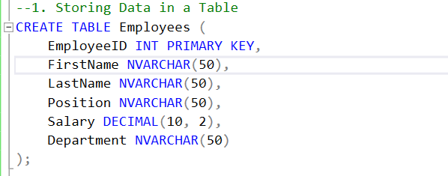

**Output:**

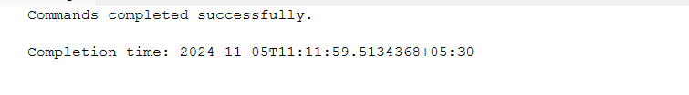

1. **Updating Data in a Table**

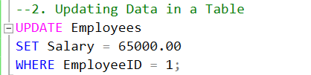

**Output:**

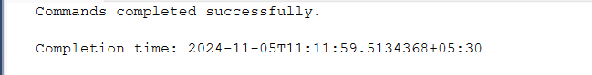

1. **Order of Execution of SQL Queries**



**Output:**

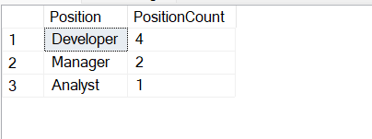

1. **Total Aggregations using SQL Queries**



**Output:**

